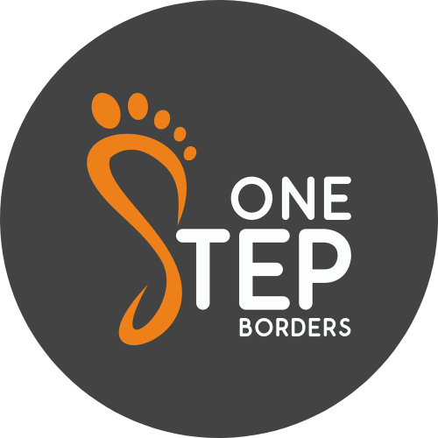

Job Description

Job Title: Mental Health Support Officer

Salary: £18 p/h Pro Rata 18-20 hours per week

Service: Mental Health Support Service

Fixed Term Contract with the possibility of extension until July 2023

Reports to: Managing Director

Location: Borders Wide

Job Purpose
To support the delivery of the overall project through:

- Caseload Holding and providing emotional and practical support in a one to one and group setting, to young people aged 16-25 who are experiencing mental health challenges
- Providing signposting and advocacy support to young people to enable them to access further support and opportunities within the community
- Engaging with young people within the Scottish Borders, to establish, build and maintain relationships
- Supporting young people to access peer mentoring and group activities whilst promoting volunteering opportunities
- Raising awareness of mental health challenges both within the community and amongst partner organisations
- Delivering support in an out of hours capacity and at weekends (6hrs per month)

We provide emotional support to young people who are experiencing emotional/mental health challenges; or are identified as vulnerable to developing mental health challenges. This support may be through telephone calls, video calls, meeting in the community, group work, therapy sessions or support to access other local services.

Role Responsibilities

- To help maintain a referral system, assess information from referring agencies and individuals to determine the appropriateness of the referral

- Assess referred individual and manage the transition of appropriate referrals into the service and where necessary refer to other services

- Develop a professional relationship with referred individuals and provide 1-1 outreach support as well as facilitating group support

- To undertake evidence based assessments and prioritise the needs of young people to develop a support plan for the individual

- Support individuals to understand and manage their own emotional and mental health needs

- Assist in matching trained volunteer mentors and befrienders

- To engage and maintain effective liaison with statutory and voluntary services working with young people and where necessary, attending relevant meetings to addressing barriers to access and helping to ensure young people receive coordinated support

- Manage a caseload of young people to ensure service delivery remains accessible and convenient

- Keep records which facilitate communication with the organisation and are compliant with all current GDPR regulations ( both on IT systems and paper files)

- Manage all requirements relating to data collection, research and audit within the service, including statistics and records, communications to referrers and others involved in care. Providing regular reports on activity within, and effectiveness of, the service at staff meetings and other ad hoc meetings with colleagues

- To signpost to other services as appropriate, helping young people not appropriate for the service to access universal services

- To ensure you have an understanding (appropriate to your role) of and comply with One Step Borders procedures for promoting and safeguarding the welfare of children and vulnerable adults

- To comply with One Step Borders Equality and Diversity Policy in every aspect of your work and positively promote the principles of this policy amongst colleagues, young people and other members of the community

- To comply with One Step Borders Health and Safety Policy, GDPR Policy and to protect your own and others health, safety and welfare at work

- To work flexibly and carry out any other reasonable duties as required

Person Specification

Qualifications

An appropriate social care, youth work or health care qualification at SCQF level 8 or above( E.g. Family Support, Social Work etc)

OR

Equivalent knowledge and experience acquired by other means

Essential Skills & Experience

- An understanding of mental distress, the emotional effects of trauma and the demands of being a young person, with the ability to empathise with the needs of young people

Experience of working in at least one of the following areas:
- Emotional Support
- Volunteering
- Mental Health
- Social Work/social care
- Youth Work

- A high level of self-awareness and demonstrated ability to practice self-care

- Highly developed interpersonal skills appropriate to establishing and maintaining effective working relationships with healthcare professionals, staff, young people, volunteers, and the wider community

- Experience of supporting and mentoring others and working as an effective member of a team

- An understanding of child and adult protection safeguarding issues with the ability to implement relevant policies and procedures

- Good IT, numeracy, record keeping and organisational skills

- Excellent verbal and written communication skills

- Ability and enthusiasm to work creatively and independently with an appropriate amount of supervision as well as being able to work well as part of a supportive team

- Knowledge of health and safety issues and an ability to take responsibility for the health, physical well-being and safety of the adults attending the service

- A current driver’s licence and access to a car that can be used for work

Desirable

- A good level of knowledge about the services available and professionals working with young people in the Scottish Borders, and an ability to contribute to the multi-disciplinary forums

- A good level of youth mental health issues along with a passion to support young people at this time

- Experience of facilitating assessments and support planning

- Experience of providing sensitive, non-judgemental support to young people

